Your first GitHub repository

1. Introduction
With this project, you'll finally be able to put into practice what you've learned about Terminal, Git, and Github! It's pretty simple, but we'll still walk you through each step.

You'll have to create your first repository, upload it to GitHub, then interact with it from your computer. Oh yeah!

2. Content of the project

2.1. Create the repository on GitHub
If not already done, go create an account on GitHub, then a new repository.
When creating the repo, GitHub will ask you:
- the repository name: give it a name like git-thp.
- a description: it's optional, so leave it empty.
- if it will be public or private: you have the choice (since the acquisition of GitHub by Microsoft, private repo are not limited anymore).
- if you want to initialize with a README: no, we will add it by hand.

📚 INFO
A README is a file that is always found in a Git repository. It allows a person who arrives on the project to better understand it, to see how it works and to have an exhaustive documentation. For example, you can see here the React JS page with its README which explains what this Javascript library (or "framework") does. For the project we are interested in, the README will be a simple text explaining that it is an introduction to GitHub, Git, and the terminal.

You should now arrive at an incomprehensible page similar to:
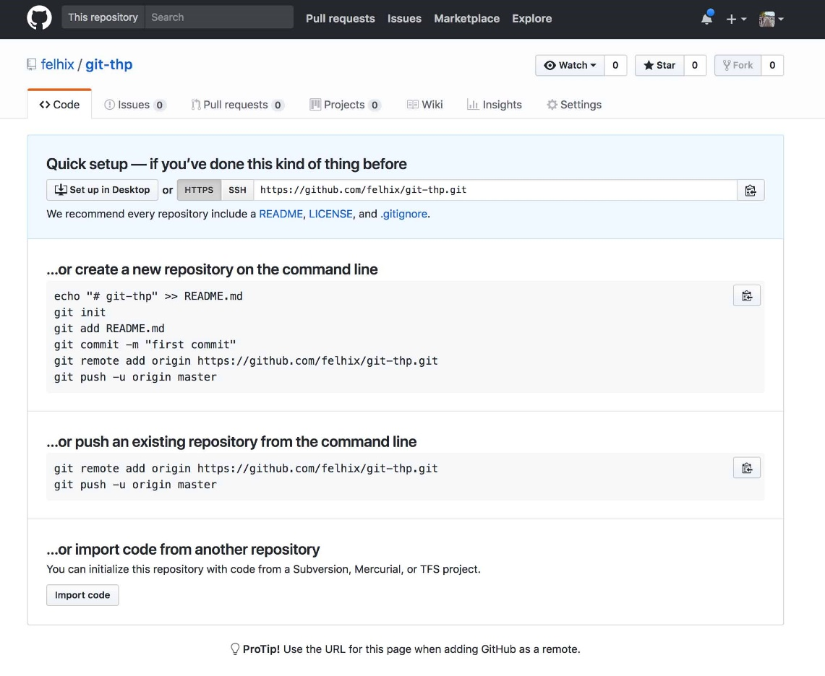
This page only tells you that your repository has been created, that it is empty and ready to be coupled to a folder on your computer. So we will take this repo, and put it on your computer.
Since you are the owner of this repo, you just have to clone it to be able to work on it. With your terminal, go to today's folder, then create a new folder for this project with mkdir. Go inside with the cd command.
Une fois dans le bon dossier, te voici prêt à cloner ton repo vide à l'aide de la commande git clone :
Once in the right folder, you are ready to clone your empty repo with the git clone command:
$ git clone https://github.com/ton_username/le_nom_de_ton_repo

🤓 RECURRING QUESTION

But tell me Jamy, what is the git clone command?
This is a very useful command to download a GitHub repository to your computer.
There you go, you've linked your first folder to a GitHub repo! From there, you can make commits, then push them to the GitHub repo.

2.2. Working on the project from your computer
Okay, let's give this file a little boost. Let's start by making a README to explain what it does.

🤓 RECURRING QUESTION

But hey Jamy, why don't I do git init, which is in theory THE first command to do in any new repo?
Excellent question, chief. It proves that you follow! Git init is used to tell your computer "hey bro, here I'm going to have a folder that will be tracked by git, so I'll make frequent backups". But since this time you made a clone, your computer already knows it's a git folder. No need to do git init!
By the way, when you make a clone, you directly associate your remote origin to the GitHub repository. You can see it by doing git remote --v. You can also see with this answer from Stack Overflow that git clone is more or less the equivalent of 5 commands.

2.2.1. Creation of the first file
With the touch command, create a new file called README.md. Open your working folder with your favorite text editor and write the following lines in the README.md file:
This is my very first GitHub repo, waow !

2.2.2. Adding the first file
If you type the git status command, your computer should say something like: "hey man! I'm on the master branch, on the first commit. I found a new file called README.md, which is not listed in the git folder when you make backups. If you want me to take it into account on your next commit, do a git add pleeease". Cool, so we'll add this file with git add.

2.2.3. First commit
Once you have added your file with git add, you can redo git status. You'll get a similar screen, but a little different. This time, your computer says "hey you! I'm on the master branch, on the first commit. You have at least one file added to the git folder that differs from the previous commit. If you make a commit now, this file will be saved! As you probably understood, it's time to make your first commit with the git commit command. As a comment, I advise you the very explicit "Adding the README".
If you type $ git log, you will be able to see the history of your different commits. If you have done the previous commit, you should see it displayed inside.

🎨 EXAMPLE

You may be wondering what the difference is between add, file creation and commit. It's true that it's easy to get lost... To clarify things, let's take an analogy: imagine that your project represents a party where each file corresponds to one of the participants. Git is used to capture pictures of the party, and to know precisely which people you are going to take pictures of.

People on the picture

From time to time, new guests will be added (file creation). It becomes necessary to specify to your computer that you want to take pictures of them too. You will use git add to choose precisely who will be present on your pictures. Sometimes, some files will not be ready to be photographed. They will have changed from the last photo (the ravages of alcohol, all that...), but you don't want to re-capture them. When you do git status, they will be untracked, which is fine. So you just add the files you want with git add.

Take the picture
Once your frame is ready (with all the people you want to take a picture of and not the others), you can do git commit to press the shutter, and add a nice comment like " the féfé band".
You can take another picture later with other files by doing git add, then git commit.

2.3. Put your project online
Now that you've made your first commit, we'll put it all online, then admire your beautiful work.
The $ git push origin master command will ask Git to put your code online. If you go to your project page (like: https://github.com/your_username/your_repo_name), your folder should be up to date and include a great README.md!

🤓 RECURRING QUESTION
But tell me Jamy, you're confusing me a bit... What does "Git push origin master" mean?
This command uses 4 words that we will dissect:
- git: you use the git program in your terminal. So far, so good.
- push: you make a push, that is to say you will push (or send) your project...
- origin: to the remote origin of your project. When you made git clone, you put your remote origin by default in the GitHub folder, but you could have pushed to your genesis remote, or your my_super_name_cool remote. You can see all your remotes by doing$ git remote -v.
- master : on the master branch.
So, if you typed $ git push heroku other_branch, you would have done a git push in your heroku remote on the other_branch branch.

2.4. Add a file
Now create a new file named kikou.txt and add it to your repository. Make a commit, then push it to your remote origin. Confirm that everything has been done by going to your GitHub repo and refreshing the page.

2.5. Shell-enge
The best way to learn is by doing. If you ever want to go further in the world of development, you'll need to handle the terminal perfectly. To help you improve, we're going to ask you to do (*drum roll*)... the SHELL-ENGE©!
This week, ALL actions you perform on your computer will have to be done with the terminal rather than with the usual explorer. For example, if you need to move a file from one folder to another, use the terminal.

It may seem useless and tedious because each action will take you longer (as long as you are not used to it), but believe me: it is an excellent way to learn how to use the terminal very quickly. So I invite you to browse Google to find the equivalent (for the terminal) of the basic functions of your explorer.

3. To go further
This part is optional. Do it only if you want to become more comfortable with Git manipulations.
To go further, reproduce the above project from the beginning, but this time WITHOUT reading the instructions. You will basically have to:
- Create a repository on Github, then import it on your computer.
- Create a README.md file then commit and push it to GitHub.
- Create a kikou.txt file then commit and push it to GitHub.

4. Expected deliverable
Here's what you'll need to deliver: https://github.com/barifche/Git-thp.git
- A GitHub repository containing two files: a README.md file and another called kikou.txt

